Welcome!

We are delighted you have chosen to study with us and look forward to working with you. Below are details of a project to help you stay creative this summer. Your outcomes won’t be assessed as part of your degree, we just want to get a sense of the kind of work you enjoy making.

……………………………………………….……………………………………

The Project Title: My Place
Express your ideas and feelings towards a real or imagined place

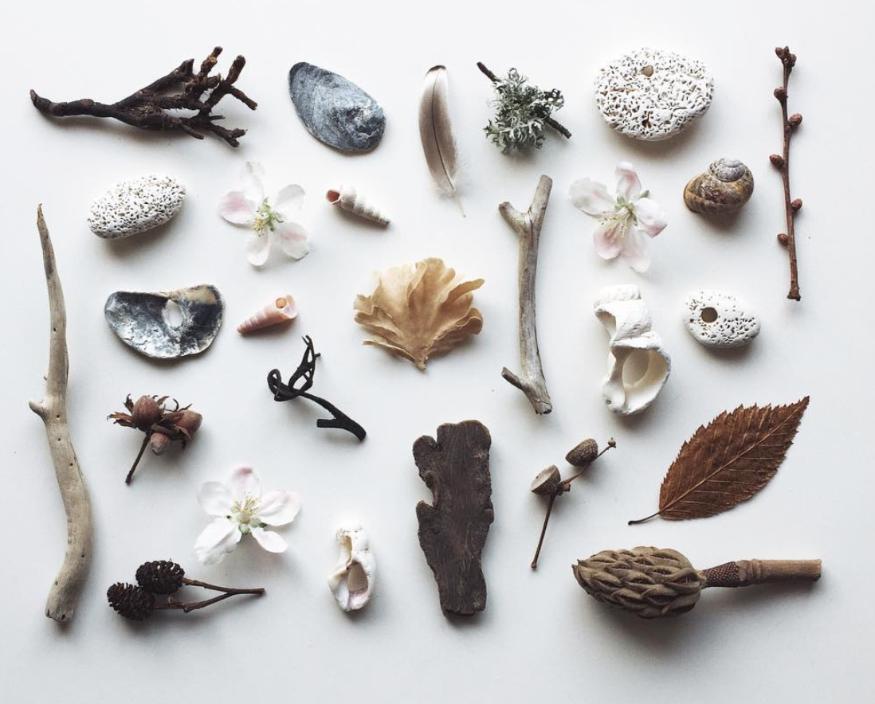Photo credit: Dorte Januszewski https://www.instagram.com/lewesmap/

We would like you to create a small but considered collection of between 5-10 found artefacts that help to communicate your relationship with your surroundings.

Over the summer we would like you to explore, seek, gather and collect objects from your local surroundings. Try to find pieces that tell a story or hold a memory. Be as playful, imaginative or conceptual as you wish, these are your found items.

Take time to explore, photograph, collect and absorb your local place. Try to take small notes during the collection phase on the time of day, location, take note of the shapes, patterns and textures these will help when you share.

During your first week you will share these mini collections with the group, they will act as a talking point of where you are from. They will also form your starting point for observation and exploration, so try to find interesting shapes or colours, patterns and textures.

Further Information

- Your programme team will look at your work during induction week
- If you like you can share your work on Instagram and other social media with us throughout the summer by posting using the hashtag #pcasummerproject
- You can take your time to explore your ideas, research if you need to but above all, enjoy it!

Join our Community

If you haven’t done so already, please follow us on social media - the general Plymouth College of Art social links are at the top of the previous page, while your programme specific links are below:

Instagram: @pca_surface pattern
@pca_textilepractices

We’re looking forward to seeing you soon - enjoy your summer!

From Cathy, Emma, Becky and Charlotte, the Textiles Programme Team

