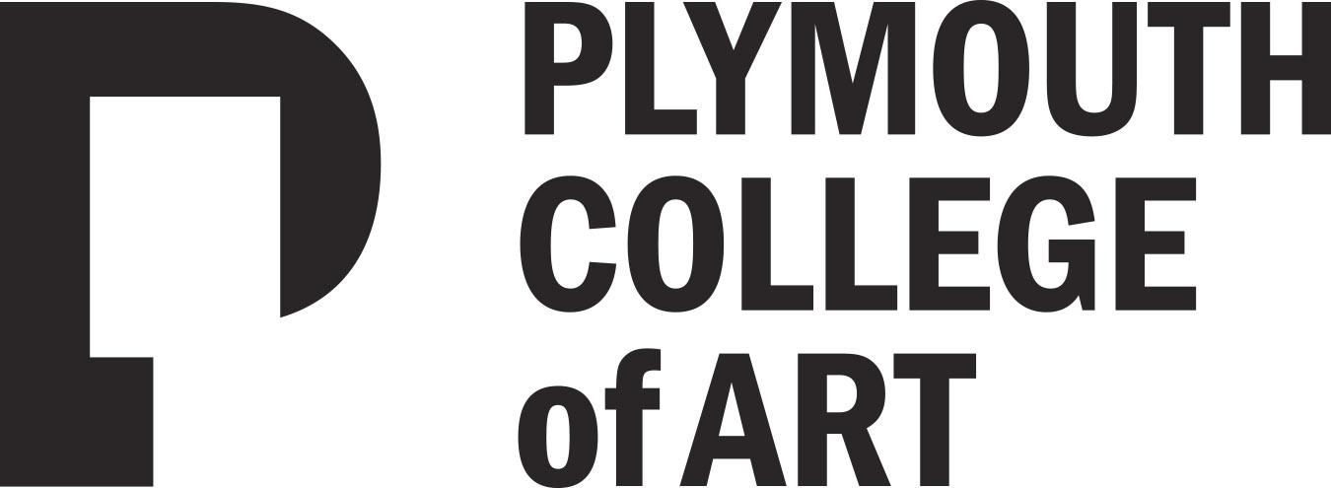

Welcome!

We are delighted you have chosen to study with us and look forward to working with you. Below are details of a project to help you stay creative this summer. Your outcomes won’t be assessed as part of your degree, we just want to get a sense of the kind of work you enjoy making.

……………………………………………….……………………………………

The Project Title: My Place

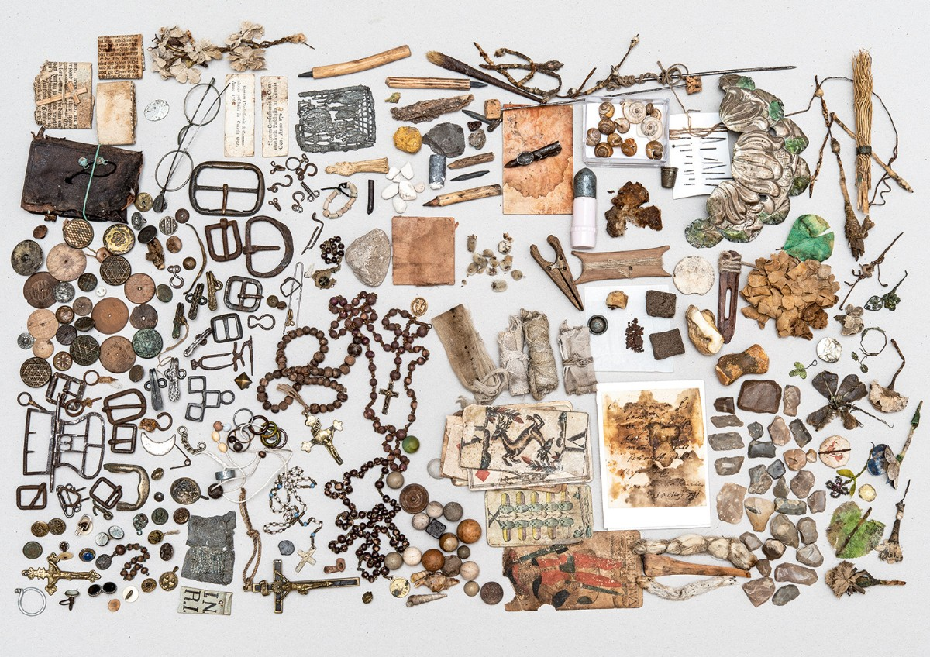
Lois Weinberger, Debris Field 2010–2016; finds from the attic, parent’s house, Stams in Tyrol, 14th to 20th century. Photo: Paris Tsitsos © Studio Weinberger

MAKE

Please find one or more things which you feel represent Your Place; we would like you to think of various things which can convey the atmosphere, identity and memory of your own location, the place you feel closer to. This can be a variety of things - physical or immaterial!

Think of ways that you can capture your environment: for example, this could be done through a series of drawings, through collecting objects and materials, or a series of photographs which would delve into its secret corners. It could be through your research on historic facts about where you are; it could also be sounds, smells, and small details that you have recorded in your walks mapping your area.

It could be any other medium, or a mix of these - this is up to you! Importantly - these would be things which you can do where you are and with what you have around you :)

Please choose at least five of these things, and bring these items with you when you arrive. During induction week we will get together and look at them. Please be ready to explain why you chose these objects or other things. This will help us to get to know each other and share our experiences of place.

LISTEN/READ

Grayson Perry’s ‘Beating the Bounds’ is a great introduction to contemporary visual art. It’s one of 4 talks he gave as part of the Reith Lectures in 2013.

https://www.bbc.co.uk/programmes/b03dsk4d

Or you can find the transcript of the lecture here:

http://downloads.bbc.co.uk/radio4/transcripts/reith-lecture2-liverpool.pdf

Listen or read, and take notes - these could be questions, ideas or an opinion. We’ll discuss this when we are all together in induction week - so bring your notes along please!

LOOK

If you get the opportunity - please visit an art exhibition or project this summer. Make some notes: What do I think about it? Does it challenge me? What is the artwork made from? (CLUE: I would do this after reading or listening to the Grayson Perry talk…).

Take notes and bring these along in the induction week.

Further Information

- Your programme team will look at your work during induction week
- If you like you can share your work on Instagram and other social media with us throughout the summer by posting using the hashtag #pcasummerproject
- You can take your time to explore your ideas, research if you need to but above all, enjoy it!

Join our Community

If you haven’t done so already, please follow us on social media - the general Plymouth College of Art social links are at the top of the previous page, while your programme specific links are below:

- Instagram: @pca_fineart
- Twitter: @PCA_FineArt
- Facebook: PCABAFINEART

HAVE AN AMAZING SUMMER AND SEE YOU IN THE AUTUMN!
From Sarah, Anti, Tom & Paul - The Fine Art Team.

