Welcome!

We are delighted you have chosen to study with us and look forward to working with you. Below are details of a project to help you stay creative this summer. Your outcomes won’t be assessed as part of your degree, we just want to get a sense of the kind of work you enjoy making.
……………………………………………….……………………………………
The Project Title: My Place

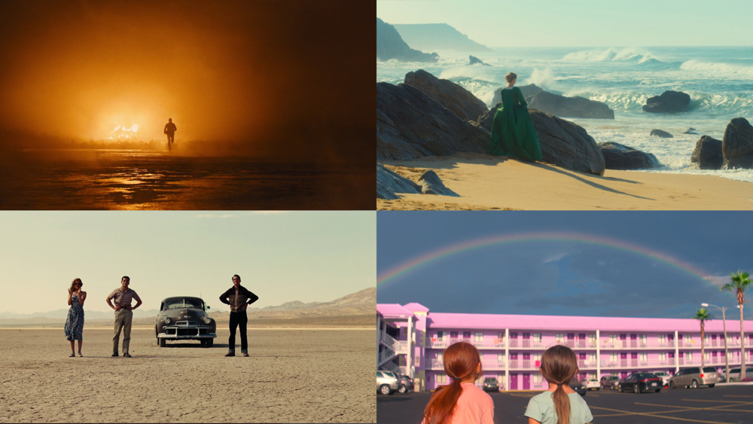
Picture Credit: www.thefilmsync.com (2019)

We want you to make a series of FIVE photographs or clips exploring light and composition in “Your Place”.

Lighting and composition make up the most important tools in any filmmakers skillset. Being able to decide how objects fit within the frame, and how light interacts with them in an image, can affect the way an audience responds to it and how colours, shadows, mood and tone create meaning. We want you to make a series of 5 photographs or short clips that capture this in a place that means something to you. This project should be something really fun and achievable whilst you are at home on your summer break.
You can use any camera you have available to you to complete this project.
- Decide on a place close to you; it may be your home, it may be somewhere you visit frequently, it could be your workplace, or somewhere you pass through whilst you’re exercising.
- Look closely at that place; look at how the light moves through it and the shadows or reflections it makes, at the objects that exist within it and the shapes and textures, the people passing by and the stories they may have.
- Photograph/film these things in the place; you could use different shot types, you could look at individual details or capture a whole scene, you could try to shoot in both portrait and landscape, or experiment with other approaches that interest you.

When you have your final images images, you are welcome to edit them or add some simple post-production, but this is not compulsory. If you do make any adjustments, please remember to make some notes about what you have done to the image, and also keep the original. We will look at all of your images when you start the programme in September.

If you would like some more inspiration for your images then you can watch “Visions of Light - The Art of Cinematography” (Glassman et al. 1992) HERE. It’s a brilliant documentary that looks at the history of cinematography throughout the 20th century and gives some great insights into the use of light and composition.

Further Information
- Your programme team will look at your work during induction week
- If you like you can share your work on Instagram and other social media with us throughout the summer by posting using the hashtag #pcasummerproject
- You can take your time to explore your ideas, research if you need to but above all, enjoy it!

Join our Community
If you haven’t done so already, please follow us on social media - the general Plymouth College of Art social links are at the top of the previous page, while your programme specific links are below:

- Instagram: @filmandscreenarts_pca
- Facebook: @@pcafilm

We’re looking forward to seeing you soon - enjoy your summer!

From the Film and Screen Arts Programme Team

