Welcome!

We are delighted you have chosen to study with us and look forward to working with you. Below are details of a project to help you stay creative this summer. Your outcomes won’t be assessed as part of your degree, we just want to get a sense of the kind of work you enjoy making.

……………………………………………….……………………………………

The Project Title: My Creative Place

Express your ideas and feelings towards a real or imagined place..

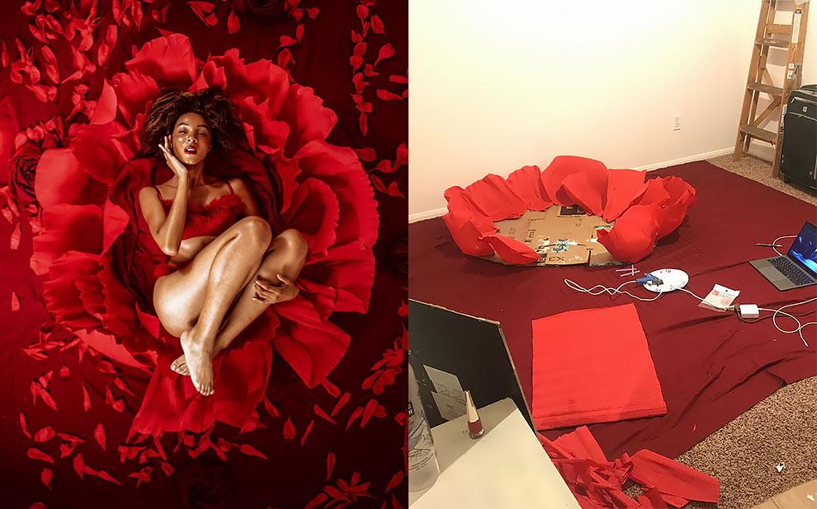
Instagram: kihmberlie

This summer we are asking our new first year students to design and photograph a creative fashion image in their home or in the local landscape. How might the place you live be adapted to construct a studio space? This is a question many of our students have faced over the past few months and we would like to share that learning with you. This is a fun task that should challenge your creativity and give us a sense of what you love about the fashion industry.

Over one week of your summer break we want you to complete the following tasks:

Day 1. Research the wonderful work of artist and model kihmberlie on Instagram
Day 2. Document a mood board of your ideas, showcasing what and/or who has inspired your shoot.
Day 3 & 4. Design a small set in your home using found materials. Ideally, these items should come from your home, you should not be required to purchase materials unless you wish to do so.
Day 5. Shoot your image on your mobile phone or camera and edit where possible.

If this all sounds very technical, let us help you to break it down into an easily manageable mini project.

DAY 1: Research kihmberlie on Instagram

DAY 2: Here are our tips on creating a mood board:
The main function of a fashion mood board is to focus the designer’s mind on the aesthetic, style and direction of the set design. Visual information relating to your research should be displayed in a simple, easy to follow format. This might be a Pinterest board, a digital collage or a simple stick and paste set of ideas on card.
- Initially, decide on a traditional or digital approach to making your mood board
- Determine the mood or theme you want to convey
- Research imagery and ideas, thinking about the place you will conceive your idea
- Identify key colours, words or phrases
- Determine objects, fabrics and textures you might want to work with to create your image
- Consider who you are making the image for
- Explore, develop and refine your images and layout
- Add your signature style, your personality is who you are, and it will carry you a long way in industry.

DAY 3 & 4: Here are our tips on creating a home studio:
Just like kihmberlie’s work, a limited number of objects can go a long way to shape your vision. From simple sheets of paper, to glass, mirrors, foil, even your bedspread, can help you to create an imaginative set design from the items you have lying around your home. Your mood board should help to determine the look and feel of your shoot based on what you have to hand. Over the course of two days we want you to document in five images how you built your set design. Please ask permission of the homeowner before you begin to build your design and we strongly recommend no student works with water or electricity until they have been fully trained to do so.

DAY 5: Here are our tips on how to shoot at home:
- Always refer to your mood board when building your set
- If you do not have much room, keep your set small
- Using natural light, the hours of sunrise and sunset will provide the most dramatic lighting, streaming through windows offering harsh shadows. During the day the light will change hour by hour. Maybe watch what is happening to your set design as you build it to determine when you might shoot.
- Play with the light maybe using your curtains or blinds to control the way the light is directed.
- Shoot on a mobile phone or camera, if you have access to one.
- Who will model for you? Will you put yourself in the picture, someone else or an object? Use your time mood boarding to decide what your featured person or piece will be.
- If you are using yourself in the image, use a self-timer and play with different poses.

We have a great online resource here to help you set up your camera and to think about creative angles.

Further Information
- Your programme team will look at your work during induction week
- If you like you can share your work on Instagram and other social media with us throughout the summer by posting using the hashtag #pcasummerproject
- You can take your time to explore your ideas, research if you need to but above all, enjoy it!

Join our Community
If you haven’t done so already, please follow us on social media - the general Plymouth College of Art social links are at the top of the previous page, while your programme specific link is:

Instagram: @pca_fcm

We’re looking forward to seeing you soon - enjoy your summer!
From the FCM Programme Team

