Welcome!

We are delighted you have chosen to study with us and look forward to working with you. Below are details of a project to help you stay creative this summer. Your outcomes won’t be assessed as part of your degree, we just want to get a sense of the kind of work you enjoy making.

……………………………………………….……………………………………

The Project Title: My Place

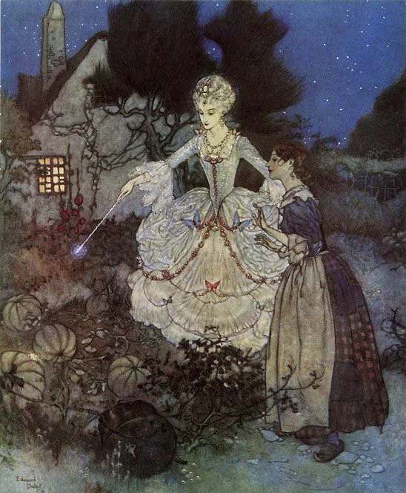
Cinderella, by Arthur Rackham

Costume Design is an exciting visual representation of a characters personality, status, age or gender for any given story. What a costume designer does is a cross between magic and camouflage. They bring character to life, in turn ask the audience for a moment in time that they really do exist!

For your summer project we would like you to express your ideas and feelings towards a real or imagined place by creating a costume based on your favourite fairy tale character.

We would like you to make your costume from everyday items found in and around Your Place. These items could be newspapers, magazines, pegs, garden wire, kitchen utensils, cardboard boxes or plastic bags. Let your imagination run riot!! However we do not expect you to purchase any materials. We would like you to spend time over the summer to work on this project and we suggest no more than one to two weeks.

The following steps below are a guide to how to plan your project :

Step 1 : Decide what character you would like to make. Then choose several images of your character which will give you a detailed view of the costume. List each part of the costume e.g collar, headdress, skirt so that you know how many parts make up the garment.

Step 2 : Collect a variety of materials for each part of your costume including materials that will attach the parts together for instance materials like; duct tape, glue, string, sellotape etc

Step 3 : Look at your costume images and decide upon which material will suit different parts of the costume best. Begin to draw out the pattern pieces and cut out.

Step 4: Assemble your costume pieces together and try the costume either on a person or on yourself. Adjust to fit if necessary.

Step 5 : Take a full length photograph of your costume in your chosen place. Keep your photos to hand; and have them with you to share with your costume year group at your induction week.

Here are some links to inspire you - we hope you enjoy making your favourite fairytale costumes!

- How to make a paper costume:
https://www.youtube.com/watch?v=To_W8TUScl4
https://www.youtube.com/watch?v=5AD9AuIIT3k

- This video features lots of unusual materials to make costumes: https://www.youtube.com/watch?v=LnukLbmyrFw

- This links to great paper folding ideas for your costume: https://www.youtube.com/watch?v=nSGq3e7QpS8

Further Information

- Your programme team will look at your work during induction week
- If you like you can share your work on Instagram and other social media with us throughout the summer by posting using the hashtag #pcasummerproject
- You can take your time to explore your ideas, research if you need to but above all, enjoy it!

Join our Community

If you haven’t done so already, please follow us on social media - the general Plymouth College of Art social links are at the top of the previous page, while your programme specific links are below:

- Instagram: @costumepca
- Twitter: costume@Plymouth Art

We’re looking forward to seeing you soon - enjoy your summer!

Best Wishes from, Marie and the Costume Programme Team

