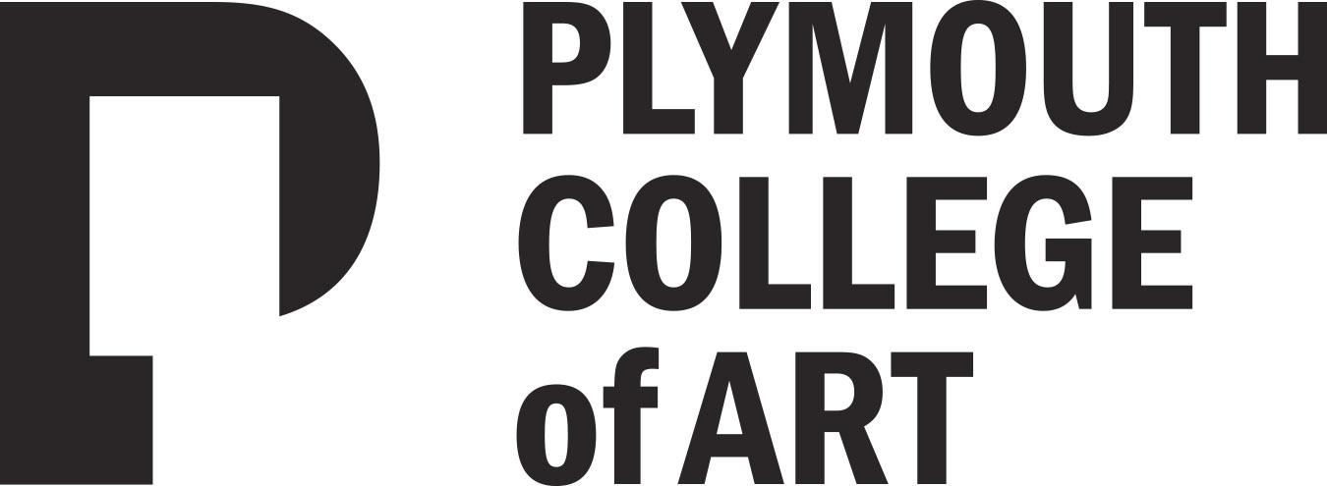

Welcome!

We are delighted you have chosen to study with us and look forward to working with you. Below are details of a project to help you stay creative this summer. Your outcomes won’t be assessed as part of your degree, we just want to get a sense of the kind of work you enjoy making.

……………………………………………….……………………………………

The Project Title: My Place

Express your ideas and feelings towards a real or imagined place

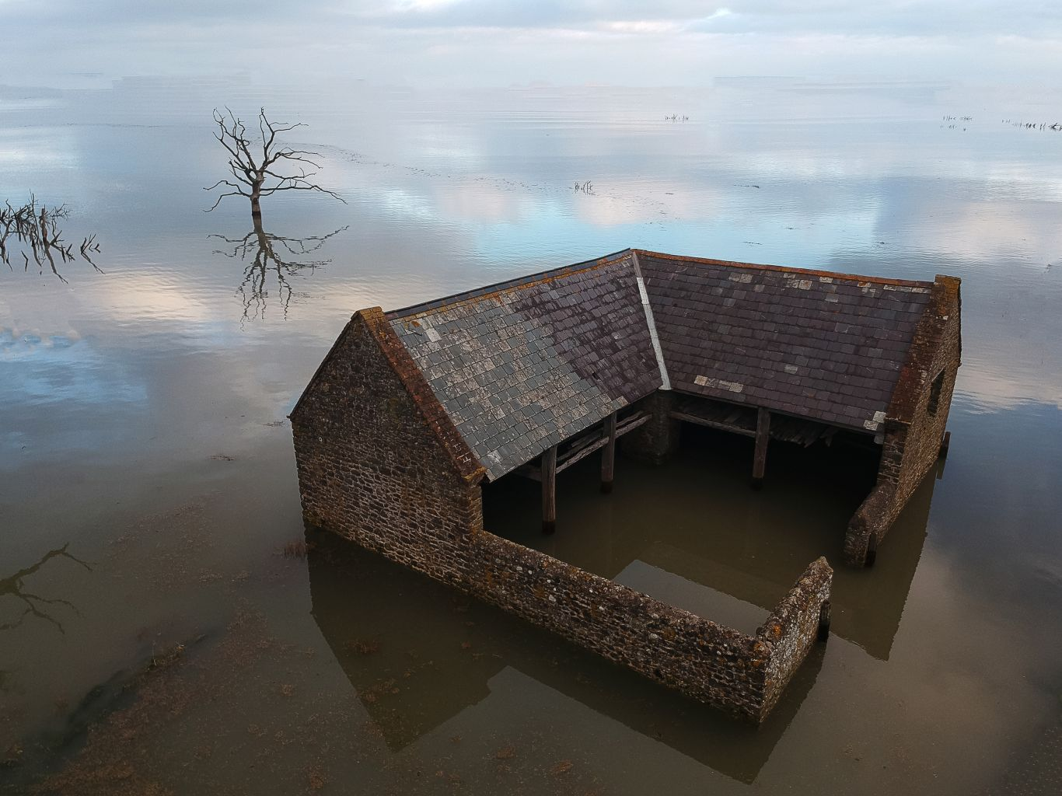
Liz Coles. BA Commercial Photography Year 3
Image shortlisted & exhibited in the AOP Student awards

You are already a photographer, that’s why you’ve decided to study for a degree, so don’t wait until September to start. Get out and make some images over the summer. We would like you to produce 3 images, that we will ask you to put up in a mini exhibition in the first few weeks of term as a means of introducing yourself and your photography to your group.

The theme for this mini project is based on an annual competition held by the AOP (The Association of Photographers). Plymouth College of Art is affiliated with the AOP, and every year our students enter the AOP Student Awards, one of the most prestigious student photographic competitions in the UK. This year three of our students, one from our 1st year, were shortlisted in the awards, their work exhibited in London and published in the annual awards book.

The AOP awards has 3 very clear categories: People, Places and Things. These are very broad categories and can be interpreted in any number of ways, offering a great deal of creative freedom.

For this project, we would like you to consider the idea of Place, and in particular your place. This could be your physical home, the town or city where you live, a favourite place that you like to visit. You could also interpret this in a less literal way. Your place can be imagined, it can be a place inside your head. Whatever the place, we are looking to see how you picture your thoughts or feelings towards it. This is an opportunity for you to express yourself

This isn’t a competition and the work won’t be assessed, we just want to get a sense of what kind of photographer you are and the kind of work you like to produce. You don’t need to use a DSLR or an expensive camera, you can use a smart phone. This isn’t a technical exercise, the emphasis should be on your creative and visual skills.

For the purposes of the mini exhibition, we will be looking to produce prints from your images, so try and capture them at the best possible quality. You will be shown how to download, edit and export your files during your induction and will also be introduced to our in-house print bureau where you will be able to get your images printed.

Further Information

- Your programme team will look at your work during induction week
- If you like you can share your work on Instagram and other social media with us throughout the summer by posting using the hashtag #pcasummerproject
- You can take your time to explore your ideas, research if you need to but above all, enjoy it!

Join our Community

If you haven’t done so already, please follow us on social media - the general Plymouth College of Art social links are at the top of the previous page, while your programme specific links are below:

Programme Blog: https://commercialphotopca.blog/
Instagram: https://www.instagram.com/commercialphotopca/
Twitter: https://twitter.com/commphotopca

We’re looking forward to seeing you soon - enjoy your summer!

From the Commercial Photography Programme Team

