Welcome!

We are delighted you have chosen to study with us and look forward to working with you. Below are details of a project to help you stay creative this summer. Your outcomes won’t be assessed as part of your degree, we just want to get a sense of the kind of work you enjoy making.
……………………………………………….……………………………………
The Project Title: My Lair
Express your ideas and feelings towards a real or imagined place

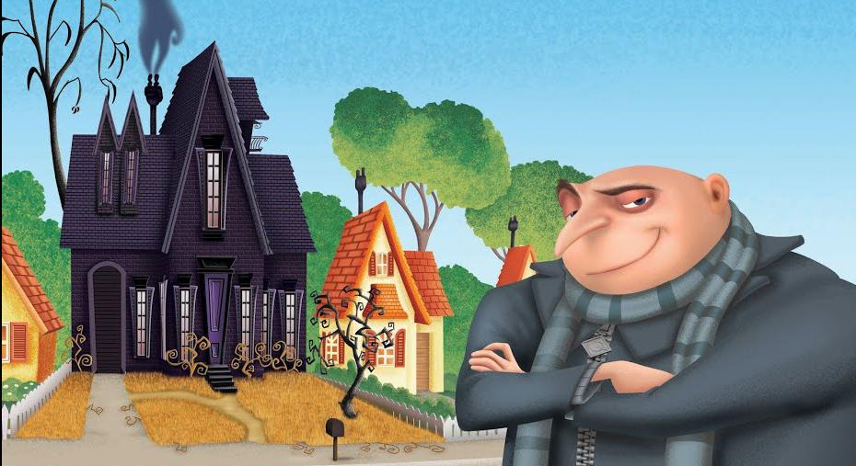
Felonius Gru in front of his distinctive home - Despicable Me 2010

The best-animation and game characters have a place, lair or home where they dwell, scheme, plot or simply go to relax or let off steam as part of a story arc.

Superman has his Fortress of Solitude in the north pole, Lara Croft has her mansion, Batman has his Bat Cave underneath Wayne mansion, Bowser has his castle, the Ninja Turtles have their home in the sewers underneath the streets of New York!

What is your place, where do you go to plot, scheme, hide or collect supplies? Where do you go to seek peace and solitude? What’s your favourite place?

YOUR TASK

Create an image of yourself as a character from a game or animated film inside or out the front of your favourite place. This can be you in front of your family home, favourite hangout, cafe, bar, den, club, skate park, surf shack, movie theatre, bowling alley, public library or any place that depicts who you are, where you are from and what sort of individual you are. You could even design your own hideout, lair or dungeon. This is a quick and fun environment and character art challenge !

It can be a sketch, painting, digital artwork, collage, 3D or whatever medium that expresses your individual character and style. It can be coloured or not. It can be any style you like.

Make sure and take a digital copy of your image. This can be scanned or a photo saved in JPEG format. Make sure and complete your image before you start your degree at PCA.

Further Information

- Your programme team will look at your work during induction week
- If you like you can share your work on Instagram and other social media with us throughout the summer by posting using the hashtag #pcasummerproject
- Or you could email your work at any point - just send to pcasummerprojects@pca.ac.uk and we will add your image to our welcome site: welcome.pca.ac.uk
- You can take your time to explore your ideas, research if you need to but above all, enjoy it!

Join our Community: PCA Animation & Games

If you haven’t done so already, please follow us on social media - the general Plymouth College of Art social links are at the top of the previous page, while your programme specific links are below:

- Facebook: https://www.facebook.com/groups/250394698339183
- Instagram: https://www.instagram.com/animation_gameart_pca/
- Twitter: https://twitter.com/PCAGameArts

We’re looking forward to seeing you soon - enjoy your summer!

From the Animation & Games Programme Team

